- What is Abstraction?
Abstraction refers to the act of representing essential features without including the background details or explanations.
- What is Encapsulation?
Encapsulation is a technique used for hiding the properties and behaviors of an object and allowing outside access only as appropriate. It prevents other objects from directly altering or accessing the properties or methods of the encapsulated object.
- How many ways we can create an object?
- New operator
- Clone
- getInstance
- class.forName() – this method internally uses getInstance()
- Deserialization
Why we need wrapper classes?
- Collection is working on wrapper classes
Q) Integer i=10; Integer j=10 what is i==j ? → TRUE
- true [till 127 it return true after 127 it will return false because its address will change after that]
- Integer i=128; Integer j=128; i==j → false [Because it exceed char range]
- Integer i=12; Integer j =new Integer(12); System.out.println(i==j); → false

Case 1):-
Integer i=12;
Integer j =new Integer(12);
System.out.println(i==j); //FALSE; Char Range no matter
Case 2):-
int i=12;
Integer j =new Integer(12);
System.out.println(i==j); //TRUE Char Range no matter

Case 3):-
int i=129;
Integer j =new Integer(129);

System.out.println(i==j); //TRUE Char Range no matter

What is throwable ?
- Throwable is a parent class of Exception.

Access Modifier :-
Public :
If a class is “public” then we can access it from anywhere, i.e from any other class located in any other packages etc.

Protected :
If class member is “protected” then it will be accessible only to the classes in the same package or to the subclasses. This modifier is less restricted from private but more restricted from public access. Usually we use this keyword to make sure the class variables are accessible only to the subclasses.
- Mean If class is in the same package then we can access protected variable/method.
- And if class is in different package then access allowed only and only for child classes.

Default :
If the class has “default access” then it can be accessed only from other classes in the same package.

Private :
Private will be accessed only with in the class.

(Least Accessible) private < default < protected < public (Most Accessible)
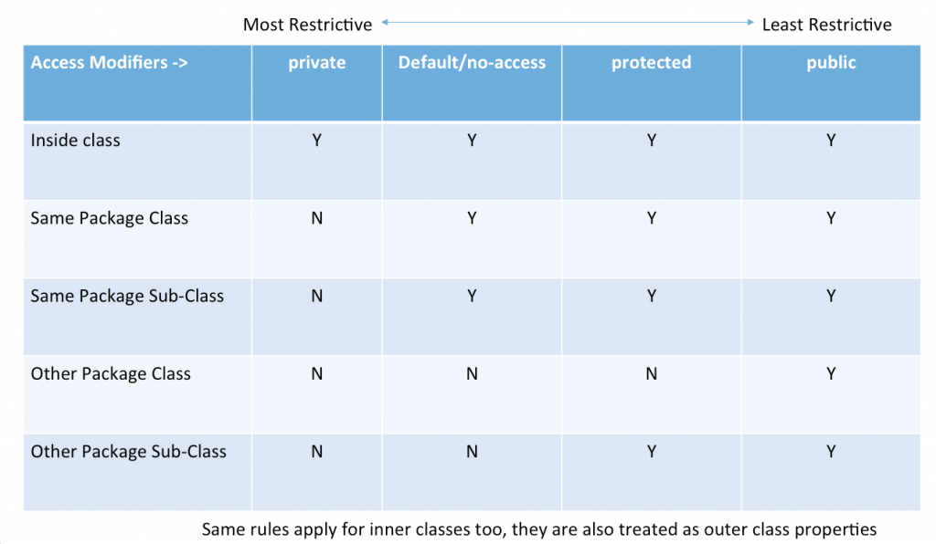

Hirerchy of Exception?
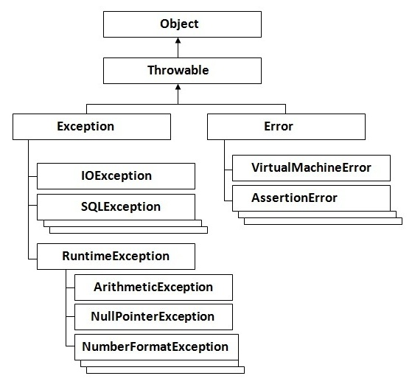

4):- final variables in Java
The final keyword in java is used to restrict the user from update.
The Final variable can be serialize. [Both blank final also]
The java final keyword can be used in many contexts. Final can be:
- variable
- method
- class
Blank Final Variable
The final keyword can be applied with the variables, a final variable that have no value it is called blank final variable or uninitialized final variable. It can be initialized in the constructor only. The blank final variable can be static also which will be initialized in the static block only.
In Java, when final keyword is used with a variable of primitive data types (int, float etc), value of the variable cannot be changed.
For example following program gives error because i is final.
public class Test {
public static void main(String args[]) {
final int i = 10;
i = 30; // Error because i is final.
}
}
When final is used with non-primitive variables (Note that non-primitive variables are always references to objects in Java), the members of the referred object can be changed. final for non-primitive variables just mean that they cannot be changed to refer to any other object
class Test1 {
int i = 10;
}

public class Test2 {
public static void main(String args[]) {
final Test1 t1 = new Test1();
t1.i = 30; // Works
t1 = new Test1() //CT ERROR CAN NOT CHANGE REFERENCE OF FINAL NON PREMITIVE OBJECT
}
}

Garbage Collection And finalize() method In Java
finalize() method In Java:
• finalize() method is a protected and non-static method of java.lang.Object class.
• This method will be available in all objects you create in java.
• This method is used to perform some final operations or clean up operations on an object before it is removed from the memory.
• you can override the finalize() method to keep those operations you want to perform before an object is destroyed.
• Here is the general form of finalize() method.

protected void finalize() throws Throwable{}

GC :-

- The gc() method is used to invoke the garbage collector to perform cleanup processing. The gc() is found in System and Runtime classes.
- Garbage collection is performed by a daemon thread called Garbage Collector(GC). GC calls the finalize() method before object is garbage collected.
- The Garbage collector of JVM collects only those objects that are created by new keyword. So if you have created any object without new, you can use finalize method to perform cleanup processing (destroying remaining objects).

Java Class Loader
Java ClassLoader loads a java class file into java virtual machine.

Types (Hierarchy) of Java Class Loaders
Java class loaders can be broadly classified into below categories:
- Bootstrap Class Loader
Bootstrap class loader loads java’s core classes like java.lang, java.util etc. These are classes that are part of java runtime environment. Bootstrap class loader is native implementation and so they may differ across different JVMs.
- Extensions Class Loader
JAVA_HOME/jre/lib/ext contains jar packages that are extensions of standard core java classes. Extensions class loader loads classes from this ext folder. Using the system environment property java.ext.dirs you can add ‘ext’ folders and jar files to be loaded using extensions class loader.
- System Class Loader
Java classes that are available in the java classpath are loaded using System class loader.

ClassNotFoundException Vs NoClassDefFoundError In Java

ClassNotFoundException In Java :
ClassNotFoundException is a run time exception which is thrown when an application tries to load a class at run time using Class.forName() or loadClass() or findSystemClass() methods and the class with specified name are not found in the classpath. For example, you may have come across this exception when you try to connect to MySQL or Oracle databases and you have not updated the classpath with required JAR files. In most of time, this exception occurs when you try to run an application without updating the classpath with required JAR files.
For example, below program will throw ClassNotFoundException if the mentioned class “oracle.jdbc.driver.OracleDriver” is not found in the classpath.
public class MainClass
{
public static void main(String[] args)
{
try
{
Class.forName("oracle.jdbc.driver.OracleDriver");
}
catch (ClassNotFoundException e)
{
e.printStackTrace();
}
}
}
java.lang.ClassNotFoundException: oracle.jdbc.driver.OracleDriver
at java.net.URLClassLoader.findClass(Unknown Source)
at java.lang.ClassLoader.loadClass(Unknown Source)
at sun.misc.Launcher$AppClassLoader.loadClass(Unknown Source)
at java.lang.ClassLoader.loadClass(Unknown Source)
at java.lang.Class.forName0(Native Method)
at java.lang.Class.forName(Unknown Source)
at pack1.MainClass.main(MainClass.java:17)

NoClassDefFoundError In Java :
NoClassDefFoundError is an error which is thrown when Java Runtime System tries to load the definition of a class and class definition is no longer available. The required class definition was present at compile time but it was missing at run time. For example, compile the below program.
class A
{

}

public class B
{
public static void main(String[] args)
{
A a = new A();
}
}
When you compile the above program, two .class files will be generated. One is A.class and another one is B.class. If you remove the A.class file and run the B.class file, Java Runtime System will throw NoClassDefFoundError like below,
Exception in thread "main" java.lang.NoClassDefFoundError: A
at MainClass.main(MainClass.java:10)
Caused by: java.lang.ClassNotFoundException: A
at java.net.URLClassLoader.findClass(URLClassLoader.java:381)
at java.lang.ClassLoader.loadClass(ClassLoader.java:424)
at sun.misc.Launcher$AppClassLoader.loadClass(Launcher.java:331)
at java.lang.ClassLoader.loadClass(ClassLoader.java:357)

Q5_:- JavaSE 7 Features
The important features of JavaSE 7 are try with resource, catching multiple exceptions etc.
  - String in switch statement (Java 7)
  - Binary Literals (Java 7)
  - The try-with-resources (Java 7)
  - Caching Multiple Exceptions by single catch (Java 7)
  - Underscores in Numeric Literals (Java 7)

Try-with-resources Statement
- The try-with-resources statement is a try statement that declares one or more resources.
- A resource is an object that must be closed after the program is finished with it.
- The try-with-resources statement ensures that each resource is closed at the end of the statement.
- Any object that implements java.lang.AutoCloseable, which includes all objects which implement java.io.Closeable, can be used as a resource.
The following example reads the first line from a file. It uses an instance of BufferedReader to read data from the file. BufferedReader is a resource that must be closed after the program is finished with it:
static String readFirstLineFromFile(String path) throws IOException {
try (BufferedReader br =
new BufferedReader(new FileReader(path))) {
return br.readLine();
}
}

Q):- What Type of resource we can use with “try-with-resource” statements :-
Ans:- Any object that implements java.lang.AutoCloseable, which includes all objects which implement java.io.Closeable, can be used as a resource.

Q6):- JavaSE 8 Features

1):- Parallel Sort [JavaSE 8]
public class Demo
{
public static void main(String args[])
{
String fruits[] = {"guava","apple","banana"};
String fruits1[] = {"guava","apple","banana"};

// before JDK 1.8, using Arrays.sort()

Arrays.sort(fruits);
System.out.println(Arrays.toString(fruits));

// with JDK 1.8, using Arrays.parallelSort()
Arrays.parallelSort(fruits1);
System.out.println(Arrays.toString(fruits1));
}
}
2):- Addition of Calendar.Builder [JavaSE 8]

Before JDK 1.8, each date field is set separately with individual methods. Each set method added as a separate statement
import java.util.Calendar; // for Calendar class
import static java.util.Calendar.*; // for static methods of Calendar class

public class Demo
{
public static void main(String args[])
{
Calendar calendar = Calendar.getInstance();
// populate calendar with individual set methods one-by-one as a separate statement
calendar.set(YEAR, 2013);
calendar.set(MONTH, APRIL);
calendar.set(DATE, 10);
calendar.set(HOUR, 8);
calendar.set(MINUTE, 56);
calendar.set(SECOND, 14);
calendar.set(AM_PM, PM);

System.out.println(calendar.getTime());

// let us see the JFK 1.8 style
// all set methods are set as one statement

Calendar calendar1 = new Calendar.Builder()
.set(YEAR, 2013)
.set(MONTH, APRIL)
.set(DATE, 10)
.set(HOUR, 8)
.set(MINUTE, 56)
.set(SECOND, 14)
.set(AM_PM, PM)
.build(); // one semicolon here

System.out.println(calendar1.getTime());
}
}
3):- Introduction of Functional Interfaces [JavaSE 8]

An interface containing only one abstract method is known as functional interface. For example, the java.lang.Runnable interface is a functional interface as it contains only one abstract method run().
A new annotation, @FunctionalInterface, is introduced to raise compilation error if an interface marked as @FunctionalInterface contains more than one abstract method.
public interface Demo
{
public abstract void display();
public abstract void show();
}
4):- Lambda Introduction [JavaSE 8]

"-> " is known as lambda expression.
import java.util.*;
public class Demo
{
public static void main(String args[])
{
List<String> alphabets = Arrays.asList("A", "B", "C", "D");

System.out.println("Printing with earlier JDK 1.5 for loop:");
for(String str : alphabets)
{
System.out.print(str + "\t");
}

System.out.println("\nPrinting with latest forEach loop introduced with JDK 1.8 with lambda usage:");
alphabets.forEach(str ->
{
System.out.print(str + "\t");
}
);
}
}

Ex: cities.forEach((String str) -> System.out.print(str + “\t”));

5) default and static methods in Interfaces:-
From Java8 We can add two type of method with implementation in interface
- default method
- static method

@FunctionalInterface
interface InterfaceWithDefaultAndStaticMethod {
void printDemo(String name);

default void defaultMethod() {
System.out.println("InterfaceWithDefaultAndStaticMethod : defaultMethod");
}

static void staticMethod() {
System.out.println("InterfaceWithDefaultAndStaticMethod : staticMethod");
}
}

@FunctionalInterface
interface InterfaceWithDefaultAndStaticMethod1 {
void printDemo(String name);

default void defaultMethod() {
System.out.println("InterfaceWithDefaultAndStaticMethod1 : defaultMethod");
}

default void defaultMethod1() {
System.out.println("InterfaceWithDefaultAndStaticMethod : defaultMethod1");
}

static void staticMethod() {
System.out.println("InterfaceWithDefaultAndStaticMethod1 : staticMethod");
}

static void staticMethod1() {
System.out.println("InterfaceWithDefaultAndStaticMethod1 : staticMethod1");
}

}

package com.akshay.lambda;

public class DefaultAndStaticInterfaceDemo
implements InterfaceWithDefaultAndStaticMethod, InterfaceWithDefaultAndStaticMethod1 {

@Override
public void defaultMethod() {
// TODO Auto-generated method stub
InterfaceWithDefaultAndStaticMethod.super.defaultMethod();
InterfaceWithDefaultAndStaticMethod1.super.defaultMethod();
}

public void printDemo(String name) {
System.out.println(name);
}

public DefaultAndStaticInterfaceDemo() {
super();
}

public static void main(String args[]) {
DefaultAndStaticInterfaceDemo obj = new DefaultAndStaticInterfaceDemo();
obj.printDemo("Akshay");
obj.defaultMethod();

InterfaceWithDefaultAndStaticMethod.staticMethod();
InterfaceWithDefaultAndStaticMethod1.staticMethod();
}

}

Output:-
Akshay
InterfaceWithDefaultAndStaticMethod : defaultMethod
InterfaceWithDefaultAndStaticMethod1 : defaultMethod
InterfaceWithDefaultAndStaticMethod : staticMethod
InterfaceWithDefaultAndStaticMethod1 : staticMethod

If we implement two interface in which we have same default method then we need to override in implementation class otherwise it will throw compile time error.

We can have multiple default method and multiple static method but only one abstract method in functional interface.
6):- Replacement of PermGen with Metaspace [JavaSE 8]
JDK 1.8 officially announced the removal of Permanent Generation (PermGen) space and in its place introduced Metaspace. In HotSpot VM, the PermGen used to give OutOfMemoryError due to depletion of space, may sometimes be caused by memory leaks while loading and unloading a J2EE applications.
Q1) What are different type of cloning in Java?
Java supports two type of cloning: - Deep and shallow cloning.
By default shallow clone is used in Java. Object class has a method clone() which does shallow cloning.

Q2) What is Shallow copy?
Ans) Shallow clone is a copying the reference pointer to the object, which mean the new object is pointing to the same memory reference of the old object. The memory usage is lower.
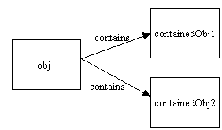
Figure 1: Original java object obj
The shallow copy is done for obj and new object obj1 is created but contained objects of obj are not copied.
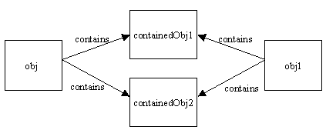
Figure 2: Shallow copy object obj1
It can be seen that no new objects are created for obj1 and it is referring to the same old contained objects. If either of the containedObj contain any other object no new reference is created.

Q3) What is deep copy and how it can be acheived?
Ans) In deep copy is the copy of object itself. A new memory is allocated for the object and contents are copied.
When a deep copy of the object is done new references are created.

Ex:-
class Subject {

private String name;

public String getName() {
return name;
}

public void setName(String s) {
name = s;
}

public Subject(String s) {
name = s;
}
}

class Student implements Cloneable {
//Contained object
private Subject subj;

private String name;

public Subject getSubj() {
return subj;
}

public String getName() {
return name;
}

public void setName(String s) {
name = s;
}

public Student(String s, String sub) {
name = s;
subj = new Subject(sub);
}

// public Object clone() {
// //shallow copy
// try {
// return super.clone();
// } catch (CloneNotSupportedException e) {
// return null;
// }
// }

public Object clone() {
//Deep copy
Student s = new Student(name, subj.getName());
return s;
}
}

public class CopyTest {

public static void main(String[] args) {
Student stud = new Student("John", "Algebra");

System.out.println("Original Object: " + stud.getName() + " - "
+ stud.getSubj().getName());

//Clone Object
Student clonedStud = (Student) stud.clone();

System.out.println("Cloned Object: " + clonedStud.getName() + " - "
+ clonedStud.getSubj().getName());

stud.setName("Dan");
stud.getSubj().setName("Physics");

System.out.println("Original Object after it is updated: "
+ stud.getName() + " - " + stud.getSubj().getName());

System.out.println("Cloned Object after updating original object: "
+ clonedStud.getName() + " - " + clonedStud.getSubj().getName());

}
}

Difference between Shallow and Deep Copy in Java

- In shallow copy main or parent object is copied, but they share same fields or children if fields are modified in one parent object other parent fields have automatic same changes occur,but in deep copy this is not the case.
- If our parent object contains only primitive value then shallow copy is good for making clone of any object because in new object value is copied but if parent object contains any other object then only reference value is copied in new parent object and both will point to same object so in that case according to our need we can go for deep copy.
- Deep copy is expensive as compare to shallow copy in terms of object creation, because it involves recursive copying of data from other mutable objects, which is part of original object.

Why Use Nested Classes?
- It is a way of logically grouping classes that are only used in one place: If a class is useful to only one other class, then it is logical to embed it in that class and keep the two together. Nesting such "helper classes" makes their package more streamlined.

- It increases encapsulation: Consider two top-level classes, A and B, where B needs access to members of A that would otherwise be declared private. By hiding class B within class A, A's members can be declared private and B can access them. In addition, B itself can be hidden from the outside world.

- It can lead to more readable and maintainable code: Nesting small classes within top-level classes places the code closer to where it is used.

What is Singleton class? Have you used Singleton before?
- Singleton is a class which has only one instance in whole application and provides a getInstance() method to access the singleton instance.
- There are many classes in JDK which is implemented using Singleton pattern like java.lang.Runtime which provides getRuntime() method to get access of it and used to get free memory and total memory in Java.
package com.akshay.SingletonDesignPattern;

public class SingletonClass implements Cloneable
{
private static SingletonClass singletonClass;

private SingletonClass()
{

}

/*public static synchronized SingletonClass getSingletonClass()
{
if(singletonClass == null)
{
singletonClass = new SingletonClass();
}
return singletonClass;
}*/

//(double locking mechanism)
public static SingletonClass getSingletonClass()
{
if(singletonClass == null)
{
synchronized (SingletonClass.class)
{
if(singletonClass == null)
{
singletonClass = new SingletonClass();
}
}
}
return singletonClass;
}

public void writeInfo(String str)
{
System.out.println(str);
}

public void writeError(String str)
{
System.out.println(str);
}

public void writeWarning(String str)
{
System.out.println(str);
}

}

package com.akshay.SingletonDesignPattern;

public class SingletonMain
{
public static void main(String args[])
{
SingletonClass Logger = SingletonClass.getSingletonClass();
SingletonClass Logger1 = SingletonClass.getSingletonClass();
SingletonClass Logger2 = SingletonClass.getSingletonClass();
SingletonClass Logger3 = SingletonClass.getSingletonClass();

Logger.writeInfo("This is called for information");
Logger.writeError("This is called for Error");
Logger.writeWarning("This is called for Warining");

System.out.println(Logger);
System.out.println(Logger1);
System.out.println(Logger2);
System.out.println(Logger3);
}
}
Output:-
This is called for information
This is called for Error
This is called for Warining
com.akshay.SingletonDesignPattern.SingletonClass@15db9742
com.akshay.SingletonDesignPattern.SingletonClass@15db9742
com.akshay.SingletonDesignPattern.SingletonClass@15db9742
com.akshay.SingletonDesignPattern.SingletonClass@15db9742

Volatile:-
- Volatile keyword in Java is used as an indicator to Java compiler and Thread that do not cache value of this variable and always read it from main memory.
- So if you want to share any variable in which read and write operation is atomic by implementation e.g. read and write in an int or a boolean variable then you can declare them as volatile variable.
- If Thread A writes to a volatile variable and Thread B subsequently reads the same volatile variable, then all variables visible to Thread A before writing the volatile variable, will also be visible to Thread B after it has read the volatile variable.
public class Singleton{
private static volatile Singleton _instance; //volatile variable

public static Singleton getInstance(){

if(_instance == null){
synchronized(Singleton.class){
if(_instance == null)
_instance = new Singleton();
}

}
return _instance;

}

If you look at the code carefully you will be able to figure out:
1) We are only creating instance one time
2) We are creating instance lazily at the time of the first request comes.
Note :- If we do not make the _instance variable volatile than the Thread which is creating instance of Singleton is not able to communicate other thread, that instance has been created until it comes out of the Singleton block, so if Thread A is creating Singleton instance and just after creation lost the CPU, all other thread will not be able to see value of _instance as not null and they will believe its still null.
Factory Design Pattern :-

package com.akshay.FactoryPatternDesignPattern;

public class PlanFactory
{
public Plan getPlan(String planType)
{
Plan plan = null;

if(planType == "monthly" )
{
plan = new MonthlyPlan();
}
else if(planType == "daily" )
{
plan = new DailyPlan();
}
else if(planType == "weekly" )
{
plan = new WeeklyPlan();
}
return plan;
}
}

-----------------------------------------------------------------
package com.akshay.FactoryPatternDesignPattern;

public class FactoryPatternMain
{
public static void main(String args[])
{
PlanFactory planFactory = new PlanFactory();

Plan plan = planFactory.getPlan("monthly");
plan.getRate();

plan = planFactory.getPlan("weekly");
plan.getRate();

plan = planFactory.getPlan("daily");
plan.getRate();

}
}

-----------------------------------------------------------------
package com.akshay.FactoryPatternDesignPattern;

public interface Plan //or it can be interface
{
int getRate();
}

-----------------------------------------------------------------
package com.akshay.FactoryPatternDesignPattern;

public class DailyPlan implements Plan
{

@Override
public int getRate() {
System.out.println("Daily Plan is called");
return 10;
}

}

-----------------------------------------------------------------
package com.akshay.FactoryPatternDesignPattern;

public class MonthlyPlan implements Plan
{

@Override
public int getRate() {
System.out.println("Montly Plan is called");
return 300;
}

}
----------------------------------------------------

package com.akshay.FactoryPatternDesignPattern;

public class WeeklyPlan implements Plan
{

@Override
public int getRate() {
System.out.println("Weekly Plan is called");
return 70;
}

}
Difference Between Static and Volatile :
Static Variable:
If two Threads(suppose t1 and t2) are accessing the same object and updating a variable which is declared as static then it means t1 and t2 can make their own local copy of the same object(including static variables) in their respective cache, so update made by t1 to the static variable in its local cache wont reflect in the static variable for t2 cache .
Static variables are used in the context of Object where update made by one object would reflect in all the other objects of the same class but not in the context of Thread where update of one thread to the static variable will reflect the changes immediately to all the threads (in their local cache).
Volatile variable:
If two Threads(suppose t1 and t2) are accessing the same object and updating a variable which is declared as volatile then it means t1 and t2 can make their own local cache of the Object except the variable which is declared as a volatile . So the volatile variable will have only one main copy which will be updated by different threads and update made by one thread to the volatile variable will immediately reflect to the other Thread.
Why we use marker interface?
Marker interface are blank interface with no method.
Note :- It is used to do some specific task. When the code is compiled then JVM check whether any marker interface is there or not. And if any marker interface is find then based on the interface it do some mechanism.
3 type:-
- Serializable
- Clonable
- Remotable

SERIALIZATION :-

[Static and Transient variable are not serialize]

Most Important Point:-

Serialization with Association

1):- If Employee has a Address as a refrence variable then Address needs to implementing the Serializable else it will throw an exception that

java.io.NotSerializableException

2):- If we are using the List<Department> then Department need to implement the serializable interface else it will throw an exception.

java.io.NotSerializableException error.

3):- If parentClass is not implemented the Serialization but child class implements the serialization then serialization and deserialization is not giving any error. But every member is initialize to its default value

Parent Class ➔ A

Child Class ➔ B implements Serializable

If A obj = new B();

Then if we serialize object “obj” it will serialize with its default value. And if we deserialize it then it will give member variable value with default value.

In this case obj is not able to access B’s property. [Normal Oops Concept]
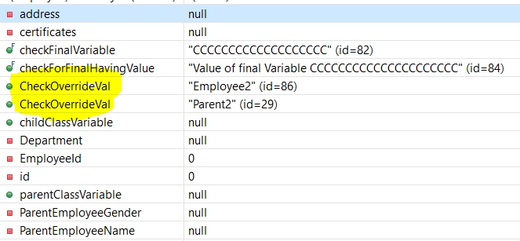

Parent Class :→ public String CheckOverrideVal = "Parent"; not implement Serilizable

Employee Class :-- public String CheckOverrideVal = "Employee"; implement Serilizable

Main Method:-
ParentEmployee emp = new Employee()
System.out.println(emp.CheckOverrideVal); “Parent” // Not Serialize
serializeObject(emp, filePath);
ParentEmployee p = (ParentEmployee)deserializeObject(filePath); // “Parent”
System.out.println(p.CheckOverrideVal); // Parent
Employee e = (Employee)deserializeObject(filePath); “Employee” //Serialize

System.out.println(e.CheckOverrideVal); //”Employee”

4):- If parent Class is not implemented the Serialization but child class implements the serialization then serialization and deserialization is not giving any error. But Parent class member is initialize to its default value

Parent Class ➔ A

Child Class ➔ B implements Serializable

If

B obj = new B();

Then if we serialize object “obj” it will serialize of B value but not serialize A value. And if we deserialize it then it will give member variable value of A with default value.

Inheritance in Java Serialization

(1) If Super class is Serializable

In case super class is Serializable than all its subclasses will be serializable by default. No need to implement serializable interface in subclass explicitly.

2) If Super class is not Serializable but subclass is

In case super class is not Serializable than to serialize the subclass’s object we must implement serializable interface in subclass explicitly. In this case the superclass must have a no-argument constructor in it.

(3) If the superclass is serializable but we don’t want the subclass to be serialized.

To prevent subclass from being serialized we must implement writeObject() and readObject() method and need to throw NotSerializableException from these methods.

serialVersionUID in Java Serialization

serialVersionUID is used to ensure that during deserialization the same class (that was used during serialize process) is loaded.

serialVersionUID is a static Final field.

It is most important for serialization process.

If you are not specifying any serialVersion id in the class then IDE will show you the warning.
- If you are not adding it jvm will do it runtime

Class Refactoring with Serialization and serialVersionUID
Serialization in java permits some changes in the java class if they can be ignored. Some of the changes in class that will not affect the deserialization process are:
- Adding new variables to the class
- Changing the variables from transient to non-transient, for serialization it’s like having a new field.
- Changing the variable from static to non-static, for serialization it’s like having a new field.

Serializable vs Externalizable
- Externalizable provides us writeExternal() and readExternal() method which gives us flexibility to control java serialization mechanism instead of relying on Java's default serialization.
- Correct implementation of Externalizable interface can improve performance of application drastically.

How many methods Serializable has? If no method then what is the purpose of Serializable interface?
- It doesn't have any method and also called Marker Interface in Java.
- When your class implements java.io.Serializable interface it becomes Serializable in Java and gives compiler an indication that use Java Serialization mechanism to serialize this object.

Deserializing a singleton in java
During serialization no parameter constructor is called, fields initialized by deserialization process or readObject() method (if you add this method into your class).
If you want to implement a serializable singleton, you should additionally add readResolve() method
readResolve() is usually called after readObject()
private Object readResolve() {
return instance;
}

Why we use Generic ?
- Code that uses generics has many benefits over non-generic code:
    - Stronger type checks at compile time.
    - A Java compiler applies strong type checking to generic code and issues errors if the code violates type safety.
    - Fixing compile-time errors is easier than fixing runtime errors, which can be difficult to find.

Yield :-
The java.lang.Thread.yield() method causes the currently executing thread object to temporarily pause and allow other threads to execute.
Difference b/w Sleep and wait
- The fundamental difference is wait() is from Object and sleep() is static method of Thread.
- The major difference is that wait() releases the lock while sleep() doesn’t releas any lock while waiting.
- The wait() is used for inter-thread communication while sleep() is used to introduce pause on execution, generally.
- The wait() should call from inside synchronize or else we get IllegalMonitorStateException while sleep() can call anywhere.
- To start thread again from wait(), you have to call notify() or notifyAll(). While in sleep(), thread gets start after specified ms/sec interval.

Q):- Why notify, notifyAll, and wait method in object class not in Thread class ?
- These methods works on the locks and locks are associated with Object and not Threads. Hence, it is in Object class.
- The methods wait(), notify() and notifyAll() are not only just methods, these are synchronization utility and used in communication mechanism among threads in Java

Thread Pool
- A thread pool manages the pool of worker threads
- it contains a queue that keeps tasks waiting to get executed.
- A thread pool manages the collection of Runnable threads and worker threads execute Runnable from the queue.
- java.util.concurrent.Executors provide implementation of java.util.concurrent.Executor interface to create the thread pool in java.

package com.journaldev.threadpool;

public class WorkerThread implements Runnable {

private String command;

public WorkerThread(String s){
this.command=s;
}

@Override
public void run() {
System.out.println(Thread.currentThread().getName()+' Start. Command = '+command);
processCommand();
System.out.println(Thread.currentThread().getName()+' End.');
}

private void processCommand() {
try {
Thread.sleep(5000);
} catch (InterruptedException e) {
e.printStackTrace();
}
}

@Override
public String toString(){
return this.command;
}
}

package com.journaldev.threadpool;

import java.util.concurrent.ExecutorService;
import java.util.concurrent.Executors;

public class SimpleThreadPool {

public static void main(String[] args) {
ExecutorService executor = Executors.newFixedThreadPool(5);
for (int i = 0; i < 10; i++) {
Runnable worker = new WorkerThread('' + i);
executor.execute(worker);
}
executor.shutdown();
while (!executor.isTerminated()) {
}
System.out.println('Finished all threads');
}

}

Output:-

pool-1-thread-2 Start. Command = 1
pool-1-thread-4 Start. Command = 3
pool-1-thread-1 Start. Command = 0
pool-1-thread-3 Start. Command = 2
pool-1-thread-5 Start. Command = 4
pool-1-thread-4 End.
pool-1-thread-5 End.
pool-1-thread-1 End.
pool-1-thread-3 End.
pool-1-thread-3 Start. Command = 8
pool-1-thread-2 End.
pool-1-thread-2 Start. Command = 9
pool-1-thread-1 Start. Command = 7
pool-1-thread-5 Start. Command = 6
pool-1-thread-4 Start. Command = 5
pool-1-thread-2 End.
pool-1-thread-4 End.
pool-1-thread-3 End.
pool-1-thread-5 End.
pool-1-thread-1 End.
Finished all threads

Thread Dump :-
- A Java thread dump is a way of finding out what every thread in the JVM is doing at a particular point in time.
- This is especially useful if your Java application sometimes seems to hang when running under load, as an analysis of the dump will show where the threads are stuck.
- You can generate a thread dump under Unix/Linux by running kill -QUIT <pid>, and under Windows by hitting Ctl + Break.

Q) what is CountdownLatch ?
CountdownLatch is used when you want to perform some task and you want this functionality will execute when one or more specified thread completes its execution.
We define count while creating object of CountdownLatch
CountDownLatch latch = new CountDownLatch(3)
It decrease count by using countDown()
latch.countDown();
In countdown latch if thread count is down to "0" then we can not reinitialize it.
package com.aaditi.multithreading;

import java.util.concurrent.CountDownLatch;
import java.util.logging.Level;
import java.util.logging.Logger;

public class CountDownLatchDemo {

public static void main(String args[]) {

final CountDownLatch latch = new CountDownLatch(3);
Thread cacheService = new Thread(new Service("CacheService", 1000, latch));
Thread alertService = new Thread(new Service("AlertService", 1000, latch));
Thread validationService = new Thread(new Service("ValidationService", 1000, latch));

cacheService.start();
alertService.start();
validationService.start();

try {
latch.await();
System.out.println("All services are up, Application is starting now");
} catch (InterruptedException ie) {
ie.printStackTrace();
}

}

}

class Service implements Runnable {
private final String name;
private final int timeToStart;
private final CountDownLatch latch;

public Service(String name, int timeToStart, CountDownLatch latch) {
this.name = name;
this.timeToStart = timeToStart;
this.latch = latch;
}

@Override
public void run() {
try {
System.out.println(name + " is going to start");
Thread.sleep(timeToStart);
System.out.println(name + " is after sleep");
} catch (InterruptedException ex) {
Logger.getLogger(Service.class.getName()).log(Level.SEVERE, null, ex);
}
System.out.println(name + " is Up");
latch.countDown(); // reduce count of CountDownLatch by 1
}
}
Output:-
AlertService is going to start
ValidationService is going to start
CacheService is going to start
ValidationService is after sleep
ValidationService is Up
AlertService is after sleep
CacheService is after sleep
CacheService is Up
AlertService is Up
All services are up, Application is starting now
8) : what is CyclicBarrier ?
It is just similiar to countDownlatch but in this we can reset the latch count if it goes to 0.
package com.multithreading;

import java.util.concurrent.BrokenBarrierException;
import java.util.concurrent.CyclicBarrier;

public class CyclicBarrierDemo {

public static void main(String args[]) throws InterruptedException, BrokenBarrierException {

CyclicBarrier barrier = new CyclicBarrier(4);
Party first = new Party(1000, barrier, "PARTY-1");
Party second = new Party(2000, barrier, "PARTY-2");
Party third = new Party(3000, barrier, "PARTY-3");
Party fourth = new Party(4000, barrier, "PARTY-4");

Party five = new Party(5000, barrier, "PARTY-5");
Party six = new Party(6000, barrier, "PARTY-6");
Party seven = new Party(7000, barrier, "PARTY-7");
Party eight = new Party(8000, barrier, "PARTY-8");

System.out.println(barrier.getNumberWaiting());

first.start();
second.start();
third.start();
fourth.start();

five.start();
six.start();
seven.start();
eight.start(); //total eight thread but barrier is of 4 size

System.out.println(Thread.currentThread().getName() + " has finished");

}

}

class Party extends Thread {
private int duration;
private CyclicBarrier barrier;

public Party(int duration, CyclicBarrier barrier, String name) {
super(name);
this.duration = duration;
this.barrier = barrier;
}

@Override
public void run() {
try {
Thread.sleep(duration);
System.out.println(Thread.currentThread().getName() + " is calling await()");
System.out.println(Thread.currentThread().getName() + " running : barrier Count is : " + barrier.getNumberWaiting() + " before");
barrier.await(); //this will reset the barrier size
System.out.println(Thread.currentThread().getName() + " running : barrier Count is : " + barrier.getNumberWaiting() + " after");
System.out.println(Thread.currentThread().getName() + " has started running again");
} catch (InterruptedException | BrokenBarrierException e) {
e.printStackTrace();
}
}
}

Output:-
0
main has finished
PARTY-1 is calling await()
PARTY-1 running : barrier Count is : 0 before
PARTY-2 is calling await()
PARTY-2 running : barrier Count is : 1 before
PARTY-3 is calling await()
PARTY-3 running : barrier Count is : 2 before
PARTY-4 is calling await()
PARTY-4 running : barrier Count is : 3 before
PARTY-4 running : barrier Count is : 0 after
PARTY-4 has started running again
PARTY-1 running : barrier Count is : 0 after
PARTY-1 has started running again
PARTY-3 running : barrier Count is : 0 after
PARTY-2 running : barrier Count is : 0 after
PARTY-2 has started running again
PARTY-3 has started running again
PARTY-5 is calling await()
PARTY-5 running : barrier Count is : 0 before
PARTY-6 is calling await()
PARTY-6 running : barrier Count is : 1 before
PARTY-7 is calling await()
PARTY-7 running : barrier Count is : 2 before
PARTY-8 is calling await()
PARTY-8 running : barrier Count is : 3 before
PARTY-8 running : barrier Count is : 0 after
PARTY-8 has started running again
PARTY-7 running : barrier Count is : 0 after
PARTY-7 has started running again
PARTY-5 running : barrier Count is : 0 after
PARTY-5 has started running again
PARTY-6 running : barrier Count is : 0 after
PARTY-6 has started running again

Q) Difference between CountdownLatch and CyclicBarrier ?
In case of CountdownLatch once latch count down to "0" it will not increase again.
But by using CyclicBarrierit can be reset again.
Q) Default threadGroup ?
System is a ThreadGroup.
Q) Difference between ExecuterService and CountdownLatch?
ExecuterService create a threadPool but countdownLatch doesn't create thread pool.

Synchronization in Java
Synchronization in java is the capability to control the access of multiple threads to any shared resource.
Java Synchronization is better option where we want to allow only one thread to access the shared resource.

Object level Locking vs. Class level Locking in Synchronization in Java

Object level locking
Object level locking is mechanism when you want to synchronize a non-static method or non-static code block such that only one thread will be able to execute the code block on given instance of the class. This should always be done to make instance level data thread safe. This can be done as below :
public class DemoClass
{
public synchronized void demoMethod(){}
}

or

public class DemoClass
{
public void demoMethod(){
synchronized (this)
{
//other thread safe code
}
}
}

or

public class DemoClass
{
private final Object lock = new Object();
public void demoMethod(){
synchronized (lock)
{
//other thread safe code
}
}
}

Class level locking
Class level locking prevents multiple threads to enter in synchronized block in any of all available instances on runtime. This means if in runtime there are 100 instances of DemoClass, then only one thread will be able to execute demoMethod() in any one of instance at a time, and all other instances will be locked for other threads. This should always be done to make static data thread safe.
public class DemoClass
{
public synchronized static void demoMethod(){}
}

or

public class DemoClass
{
public void demoMethod(){
synchronized (DemoClass.class)
{
//other thread safe code
}
}
}

or

public class DemoClass
{
private final static Object lock = new Object();
public void demoMethod(){
synchronized (lock)
{
//other thread safe code
}
}
}

Error Vs Exception:-
Errors | Exceptions
Errors in java are of type java.lang.Error. | Exceptions in java are of type java.lang.Exception.
All errors in java are unchecked type. | Exceptions include both checked as well as unchecked type.
Errors happen at run time. They will not be known to compiler. | Checked exceptions are known to compiler where as unchecked exceptions are not known to compiler because they occur at run time.
It is impossible to recover from errors. | You can recover from exceptions by handling them through try-catch blocks.
Errors are mostly caused by the environment in which application is running. | Exceptions are mainly caused by the application itself.
Examples :  java.lang.StackOverflowError, java.lang.OutOfMemoryError | Examples :  Checked Exceptions : SQLException, IOException  Unchecked Exceptions : ArrayIndexOutOfBoundException, ClassCastException, NullPointerException

ExceptionHandling with MethodOverriding in Java
There are many rules if we talk about methodoverriding with exception handling. The Rules are as follows:
- If the superclass method does not declare an exception
  - If the superclass method does not declare an exception, subclass overridden method cannot declare the checked exception but it can declare unchecked exception.
- If the superclass method declares an exception
  - If the superclass method declares an exception, subclass overridden method can declare same, subclass exception or no exception but cannot declare parent exception
- If parent class declare checked exception then child class can declare same exception or runtime exception
class ParentClass
{
public void checkExceptionOverriding() throws IOException
{
}
}
public class BasicsMain extends ParentClass
{
public void checkExceptionOverriding() throws ArithmeticException
{
}
}

4):- Error :- If parent class declare runtime(checked) exception then child class can not declare compileTime (checked) exception
//CT Error

class ParentClass
{
public void checkExceptionOverriding() throws RuntimeException
{

}

}
public class BasicsMain extends ParentClass
{
public void checkExceptionOverriding() throws IOException //Error CT Error
{
}
}

Case 1):-
import java.io.*;
class Super
{
void show()
{
System.out.println("parent class");
}
}

public class Sub extends Super
{
//void show() throws ArrayIndexOutOfBoundsException //Correct RuntimeExc(Unchked)
//void show() throws AirthmaticException //Correct RuntimeExc(Unchked)
//void show() throws IOException //Compile time error CompileTimeExc(chked)
void show() throws Exception //can not declare CTError
{
System.out.println("parent class");
}
public static void main( String[] args )
{
Super s=new Sub();
s.show();
}
}

Case 2 :-
import java.io.*;
class Super
{
void show() throws Exception
{ System.out.println("parent class"); }
}

public class Sub extends Super {
// if parent class declare an exception then we can declare subClass any exception , same exception but can not declare parent class exception
//void show() throws Exception //Correct
// void show() throws ArithmeticException //Correct
// void show() throws IOException //Correct
void show() //Correct
{
System.out.println("child class");
}
public static void main(String[] args)
{
try {
Super s=new Sub();
s.show();
}
catch(Exception e){}
}
}

Comparable :-
- Comparable interface is used to sort the objects of user-defined class
- It found in java.lang.
- For this class must implement the comparable interface and override the compareto method. And you do your custom functionality in compareto method for comparision.

Ex:- You have User class having the name , id and City.
package com.akshay.Comparable;

public class User implements Comparable<User>
{
private int Id;
private String Name;
private String City;

public User(int Id, String Name, String City)
{
this.Id = Id;
this.Name = Name;
this.City = City;
}

//create setter and getter

//this logic sort the users data based on name as well as city
@Override
public int compareTo(User user)
{
User temp = this;
int i = temp.getName().compareTo(user.getName());
if(i == 0)
{
i = temp.getCity().compareTo(user.getCity());
}
return i;
}

public String toString()
{
return "Id :- " + this.Id + " , Name :- " + this.Name + " , City :- " + this.City;
}
}

package com.akshay.Comparable;

import java.util.ArrayList;
import java.util.Collection;
import java.util.Collections;
import java.util.Iterator;
import java.util.List;

public class ComparableTest {

public static void main(String[] args)
{
List<User> users = new ArrayList<User>();

users.add(new User(1, "Akshay Gupta", "Noida"));
users.add(new User(2, "Sahi. Gupta", "Hyderabad"));
users.add(new User(3, "Karan Gupta", "Noida"));
users.add(new User(4, "Rahul Gupta", "Pune"));
users.add(new User(5, "Akshay Gupta", "Hyderabad"));

Collections.sort(users);
System.out.println(users);
}
}

Output :-
[Id :- 5 , Name :- Akshay Gupta , City :- Hyderabad, Id :- 1 , Name :- Akshay Gupta , City :- Noida, Id :- 3 , Name :- Karan Gupta , City :- Noida, Id :- 4 , Name :- Rahul Gupta , City :- Pune, Id :- 2 , Name :- Sahi. Gupta , City :- Hyderabad]

Comparator :-
- Comparator interface is used to order the objects of user-defined class.
- It found in java.util package.
- For this class must implement the comparator interface and override the compare method. And you do your custom functionality in compare method for comparision.
- It provide multiple sorting sequence.
- Ex: we can use it in sorting in Grid like name , City, Department basic separately or you can use together.
package com.akshay.Comparator;

import java.util.Comparator;

public class EmployeeNameComparator implements Comparator<Employee>
{

@Override
public int compare(Employee emp1, Employee emp2) {
return emp1.getName().compareTo(emp2.getName());
}
}

package com.akshay.Comparator;

import java.util.Comparator;

public class EmployeeNameAndCityBothComparator implements Comparator<Employee>
{
@Override
public int compare(Employee emp1, Employee emp2) {
int i = emp1.getName().compareTo(emp2.getName());
if( i == 0 )
{
i = emp1.getCity().compareTo(emp2.getCity());
}
return i;
}
}

package com.akshay.Comparator;

import java.util.Comparator;

public class EmployeeCityComparator implements Comparator<Employee>
{

@Override
public int compare(Employee emp1, Employee emp2) {
return emp1.getCity().compareTo(emp2.getCity());
}
}

package com.akshay.Comparator;
mport java.util.ArrayList;
import java.util.Collection;
import java.util.Collections;
import java.util.Iterator;
import java.util.List;

public class ComparatorTest {

public static void main(String[] args)
{
List<Employee> users = new ArrayList<Employee>();

users.add(new Employee(1, "Akshay Gupta", "Noida"));
users.add(new Employee(2, "Sahi. Gupta", "Hyderabad"));
users.add(new Employee(3, "Karan Gupta", "Noida"));
users.add(new Employee(4, "Rahul Gupta", "Pune"));
users.add(new Employee(5, "Akshay Gupta", "Hyderabad"));

System.out.println("Before Sorting");
System.out.println(users);
System.out.println();
Collections.sort(users,new EmployeeNameComparator());
System.out.println(users);

Collections.sort(users,new EmployeeCityComparator());
System.out.println(users);

Collections.sort(users,new EmployeeNameAndCityBothComparator());
System.out.println(users);//Note :- If you want to sort based on Name and City then you can do so.
}
}

Best Question Of COLLECTIONS :-

LinkedList
How LinkedList internally store value and how they mentain the insertion order?

public class LinkedTest
{
public static void main(String args[])
{
LinkedList<String> ls = new LinkedList<String>();
ls.add("X");
ls.add("Y");
ls.add("Z");
ls.add("A");
ls.add("D");

for (String string : ls) {
System.out.println(string);
} }
}
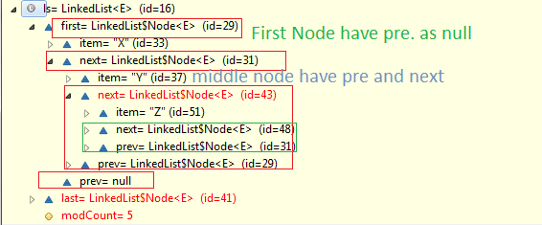

Note:-

- LinkedList Store starting value in “first” and Ending value in “last” node.
- It can store duplicate elements
- First Node contain “value” in “item” and as well as “next” and “prev” node contain value of next and previous node
- By using prev and next node it will maintain insertion order
- First node contain prev as null because of it is the first node.
- Last node contain next as null because of it is last node.

LINKEDHASHSET
How LinkedHashSet internally store value if they have hashing mechanism and how they maintain the insertion order ?

public class LinkedTest
{
public static void main(String args[])
{
LinkedHashSet<String> list = new LinkedHashSet<String>();
list.add("Akshay");
list.add("Karan");
list.add("Sandy");
list.add("Priya");
list.add("Shikha");
for (String string : list) {
System.out.println(string);
} }
}

Note:-
- LinkedHashSet Store starting first value in “head” and Ending value in “tail” node.
- Head Node contain “value” in “Key” and as well as “after” and “before” node contain value of “next” and “previous” node
- By using “after” and “before” node it will maintain insertion order
- First node contain “before” as null because of it is the first node.
- Last node contain “next” as null because of it is last node.
- Set internally use map. So LinkedHashSet internally use LinkedHashMap
- Set or LinkedHashSet can not insert duplicate element.
- It internally maintain one table in which they store value based on hashing mechanism

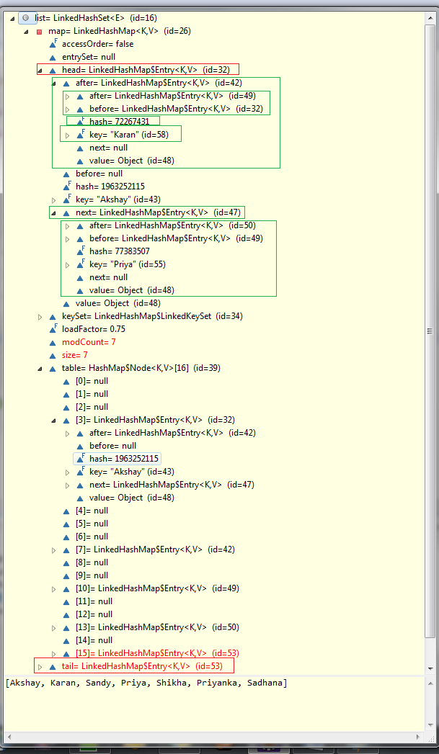
LINKEDHASHMAP
How LinkedHashMap internally store value if they have hashing mechanism and how they mentain the insertion order ?

public class LinkedTest
{
public static void main(String args[])
{
LinkedHashMap<String, Integer> linkedMap =new LinkedHashMap<String,Integer>();
linkedMap.put("Akshay", 1);
linkedMap.put("Karan", 10);
linkedMap.put("Sahil", 12);
linkedMap.put("Prem", 32);
linkedMap.put("Karan", 45);
for (Entry<String,Integer> entry : linkedMap.entrySet()) {
System.out.println(entry.getKey() + " : " + entry.getValue());
}
}
}

Note:-
- LinkedHashMap Store starting first value in “head” and Ending value in “tail” node.
- Head Node contain “value” in “Key” and as well as “after” and “before” node contain value of “next” and “previous” node
- By using “after” and “before” node it will maintain insertion order
- First node contain “before” as null because of it is the first node.
- Last node contain “next” as null because of it is last node.
- Set or LinkedHashMap will override if we insert same key value after checking its hashcode and equality.
- It internally maintain one table in which they store value based on hashing mechanism

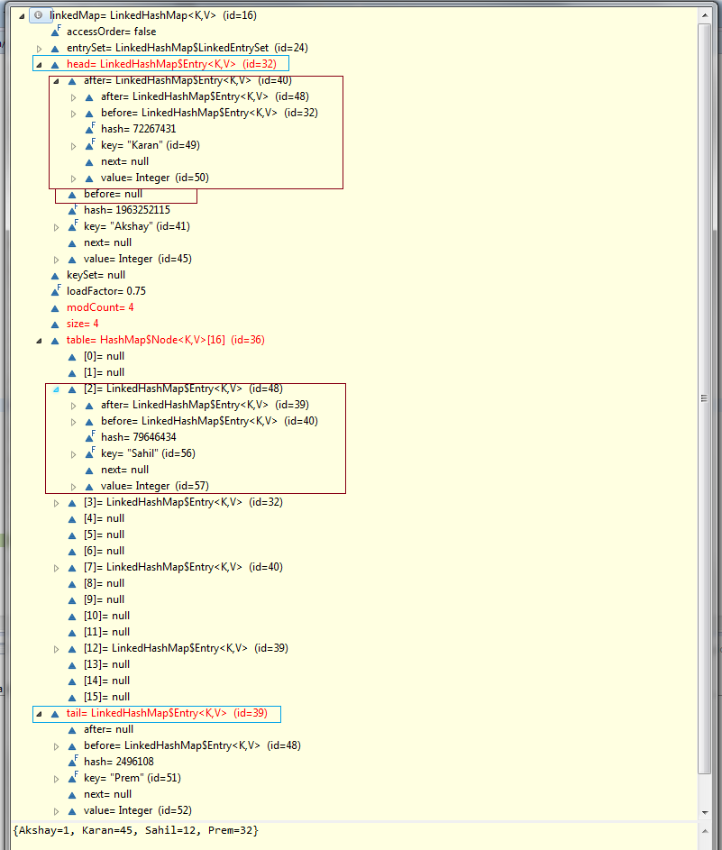

4):- How LinkedHashMap internally store value if they have hashing mechanism and how they maintain the insertion order and What happened in LinkedHashMap if the Object is used as key

class Employee {
public int Id;
public String Name;

public Employee (int id, String name) {
this.Id = id;
this.Name = name;
}

@Override
public int hashCode() {
return this.Id;
}

@Override
public boolean equals(Object obj) {
Employee emp = (Employee)obj;
return this.Name.equals(emp.Name);
}
}

public class LinkedTest
{
public static void main(String args[])
{
LinkedHashMap<Employee, String> linkedHashMap = new
LinkedHashMap<Employee, String>();
linkedHashMap.put(new Employee (809, "Akshay"), "Akshay");
linkedHashMap.put(new Employee (801, "Karan"), "Karan");
linkedHashMap.put(new Employee (805, "sahil"), "Sahil");
linkedHashMap.put(new Employee (809, "Guru"), "Guru");

for (Entry<Employee, String> entry : linkedHashMap.entrySet()) {
System.out.println(((Employee)entry.getKey()).Id + " " + ((Employee)entry.getKey()).Name + " : " + entry.getValue());
} }
}

Note:-
- If we use Object as key in Map then if we are not override hashCode and equals methods then will not return same hashCode for everyObject which have same property. So its better to provide hashCode so that you can return hashCode based on your requirement and check equality based on your requirement .

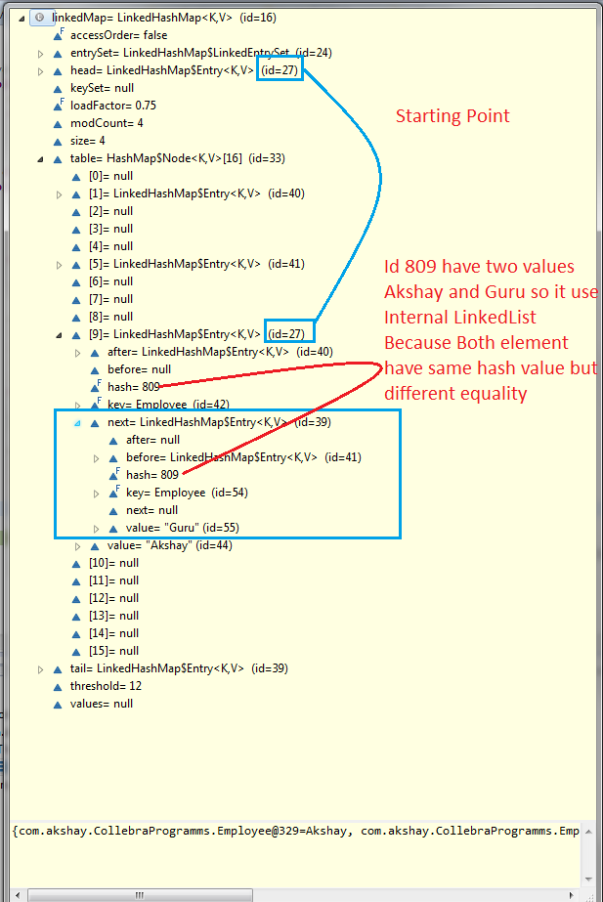
Hash Set
- It internally store element based on hashCode.
- It maintain table internally to store element.
- It internally maintain HashMap.
- It does not contain duplicate element. And it check duplicity by using hashCode and equal.

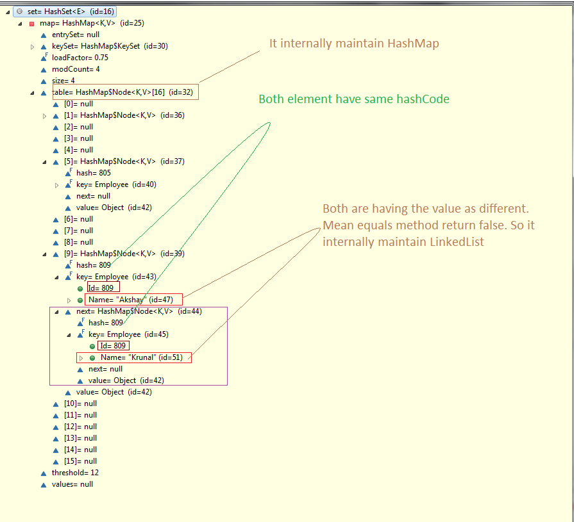

Tree Set
- It doesnot allow duplicate.
- It check duplicity by using the compare/compareTo method. If it return 0 then It will not allow element to add into treeSet

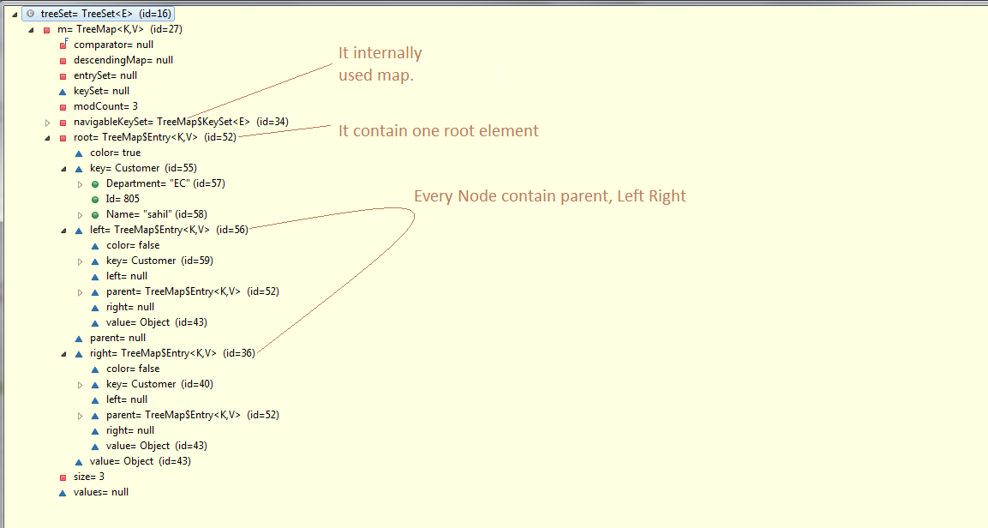

package com.akshay.CollebraProgramms;

import java.util.ArrayList;
import java.util.HashSet;
import java.util.Map.Entry;
import java.util.TreeMap;
import java.util.TreeSet;

class Customer implements Comparable<Customer> {
public int Id;
public String Name;
public String Department;

public Customer(int id, String name, String department) {
this.Id = id;
this.Name = name;
this.Department = department;
}

@Override
public int hashCode() {
return this.Id;
}

@Override
public boolean equals(Object obj) {
Customer emp = (Customer) obj;
return this.Name.equals(emp.Name);
}

@Override
public int compareTo(Customer emp) {
return this.Id == emp.Id ? 0 : this.Id > emp.Id ? 1 : -1;
}

}

public class TreeTest {
public static void main(String args[]) {
TreeSet<Customer> treeSet = new TreeSet<Customer>();
treeSet.add(new Customer(809, "Akshay", "IT"));
treeSet.add(new Customer(801, "Karan", "CS"));
treeSet.add(new Customer(805, "sahil", "EC"));
treeSet.add(new Customer(809, "Rahul", "ME")); //Not allowed
treeSet.add(new Customer(801, "Karan", "PK")); // Not allowed
for (Customer Customer : treeSet) {
System.out.println(Customer.Id + " " + Customer.Name+ " " + Customer.Department);
}
}
}
Output :-
801 Karan CS
805 sahil EC
809 Akshay IT

MAP :-

- It’s an interface
- It store value in key value pair.
- If you want unique element then you use this interface.
- Value store in key and value pair
- Fetch value based on key
Three type :- Hashmap and tree map and LinkedHashMap

a):- Tree Map:- for sorting use tree map

- A TreeMap contains values based on the key. It implements the NavigableMap interface and extends AbstractMap class.
- It contains only unique elements.
- It cannot have null key but can have multiple null values.
- It is same as HashMap instead maintains ascending order.
- It uses Left and Right node to store values Based on it return ascending or descending Order.
- If we use Object as Key then its necessary to implement Comparable or Comparator and override compare method to check the objects less then or Greater then value.
- If Compare/CompareTo method return 0 then it will override then it will not change the “key” but it override “Value”

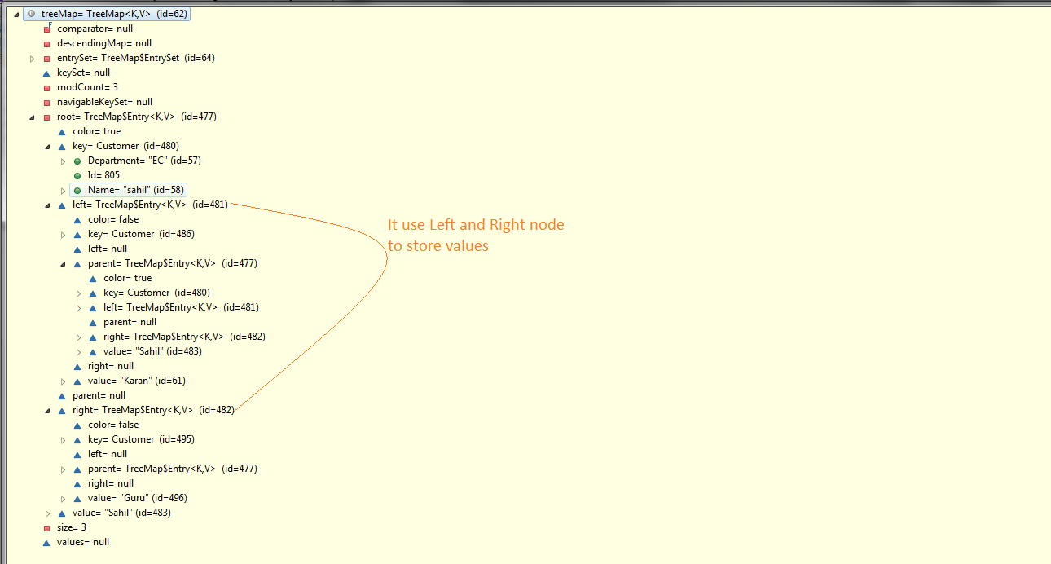

package com.akshay.CollebraProgramms;

import java.util.ArrayList;
import java.util.HashSet;
import java.util.Map.Entry;
import java.util.TreeMap;
import java.util.TreeSet;

//For TreeSet/TreeMap its mandatory to implement Comparable/Comparator
class Customer implements Comparable<Customer> {
public int Id;
public String Name;
public String Department;

public Customer(int id, String name, String department) {
this.Id = id;
this.Name = name;
this.Department = department;
}

//For TreeSet/TreeMap its mandatory to override Compare/CompareTo method
@Override
public int compareTo(Customer emp) {
return this.Id == emp.Id ? 0 : this.Id > emp.Id ? 1 : -1;
}

}

public class TreeTest {
public static void main(String args[]) {

TreeMap<Customer, String> treeMap = new TreeMap<Customer, String>();
treeMap.put(new Customer(809, "Akshay", "IT"), "Akshay");
treeMap.put(new Customer(801, "Karan", "CS"), "Karan");
treeMap.put(new Customer(805, "sahil", "EC"), "Sahil");
treeMap.put(new Customer(809, "Akshay", "ME"), "Guru");
treeMap.put(new Customer(805, "SRK", "EC"), "SRK");

for (Entry<Customer, String> entry : treeMap.entrySet()) {
System.out.println(((Customer) entry.getKey()).Id + " " + ((Customer) entry.getKey()).Name + " " + ((Customer) entry.getKey()).Department + " : " + entry.getValue());
}
}
}

Output:-
801 Karan CS : Karan
805 sahil EC : SRK
809 Akshay IT : Guru
Here 809 is equal for both object [Akshay,IT➔ Akshay] and [Akshay, ME➔ Guru] So it made Key value as [Akshay IT ➔ Guru]

Hash map :-
- A HashMap contains values based on the key. It implements the Map interface and extends AbstractMap class.
- It contains only unique elements.
- It may have one null key and multiple null values.
- It maintains no order.

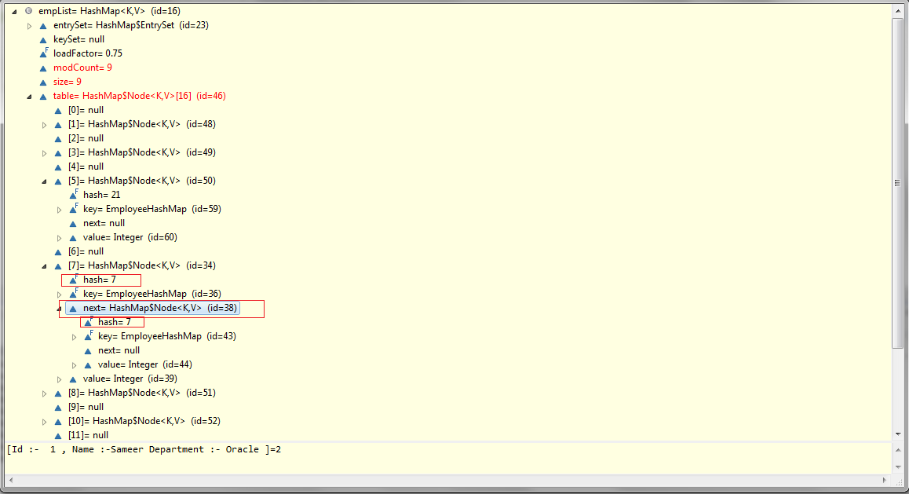

Here elimination mean if the keys are same then it will override previous one and store latest value.
Ex:-
If you are inserting set like:-
Input:-
Key Value
1 “A”
2 “B”
3 “C”
4 “D”
4 “E”

Then 4 with “D” will be override with “E”
And output will be
Output:-

Key Value
1 “A”
2 “B”
3 “C”
4 “E” Latest value.

Note:-
Note:- It may be key are different but their hashCode value same then this is called collision. It is handled by internally maintain linked list for same type of hash coded values.

Hash Table :-
- A HashTable is same as HashMap But it is synchronized.

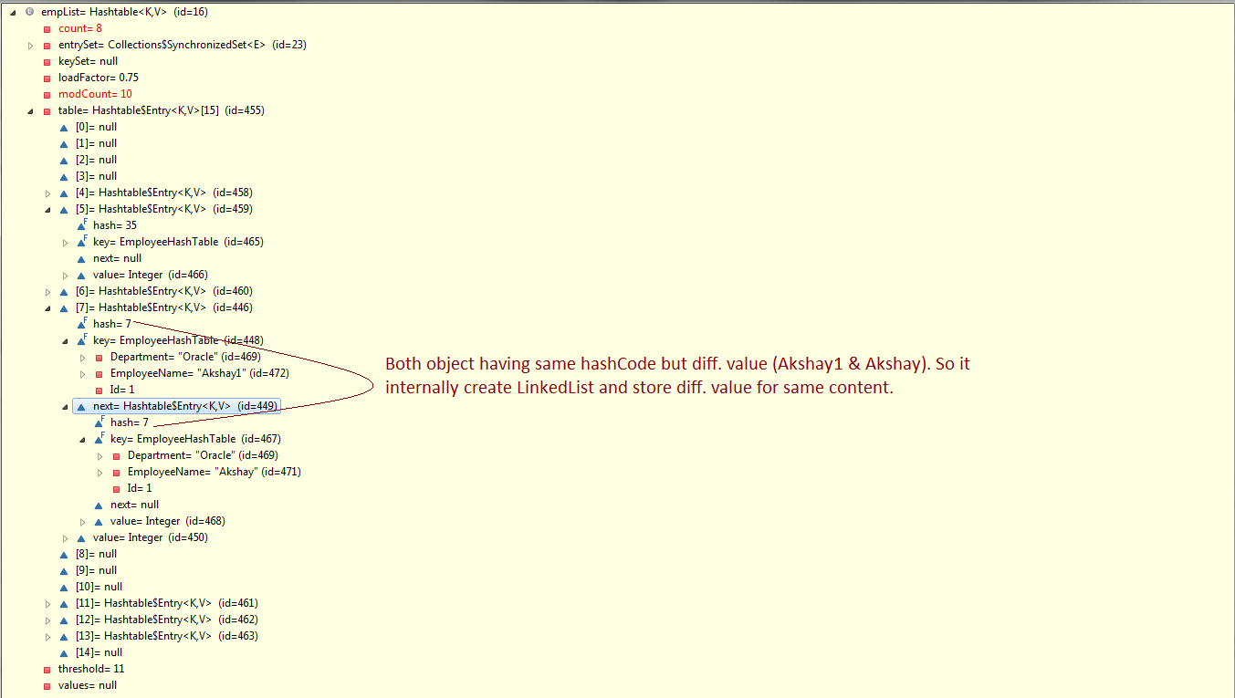

Differences between HashMap and Hashtable ?
There are several differences between HashMap and Hashtable in Java:
- Hashtable is synchronized, whereas HashMap is not. This makes HashMap better for non-threaded applications, as unsynchronized Objects typically perform better than synchronized ones.
- Hashtable does not allow null keys or values. HashMap allows one null key and any number of null values.
- One of HashMap's subclasses is LinkedHashMap, so in the event that you'd want predictable iteration order (which is insertion order by default), you could easily swap out the HashMap for a LinkedHashMap. This wouldn't be as easy if you were using Hashtable.
Since synchronization is not an issue for you, I'd recommend HashMap. If synchronization becomes an issue, you may also look at ConcurrentHashMap.

ConcurrentHashMap
- You should use ConcurrentHashMap when you need very high concurrency in your project.
- It is thread safe without synchronizing the whole map.
- Reads can happen very fast while write is done with a lock.
- There is no locking at the object level.
- The locking is at a much finer granularity at a hashmap bucket level.
- ConcurrentHashMap doesn’t throw a ConcurrentModificationException if one thread tries to modify it while another is iterating over it.
- ConcurrentHashMap is fail safe map
- ConcurrentHashMap uses multitude of locks.

SynchronizedHashMap
- Synchronization at Object level.
- Every read/write operation needs to acquire lock.
- Locking the entire collection is a performance overhead.
- This essentially gives access to only one thread to the entire map & blocks all the other threads.
- It may cause contention.
- SynchronizedHashMap returns Iterator, which fails-fast on concurrent modification.

Strong, Weak, Soft and Phanton Reference :

- Depending upon how objects are garbage collected, references to those objects in java are grouped into 4 types. They are,
1) Strong References
2) Soft References
3) Weak References
4) Phantom References

1) Strong References
These type of references we use daily while writing the code. Any object in the memory which has active strong reference is not eligible for garbage collection. For example, in the below program, reference variable ‘a’ is a strong reference which is pointing to class A-type object. At this point of time, this object can’t be garbage collected as it has strong reference.

?
1  2  3  4  5  6  7  8  9  10  11  12  13  14 | class A  {  //Class A  }  public class MainClass  {  public static void main(String[] args)  {  A a = new A(); //Strong Reference  a = null; //Now, object to which 'a' is pointing earlier is eligible for garbage collection.  }  }

If you make reference ‘a’ to point to null like in Line 12, then, object to which ‘a’ is pointing earlier will become eligible for garbage collection. Because, it will have no active references pointing to it. This object is most likely to be garbage collected when garbage collector decides to run.
Look at the below picture for more precise understanding.
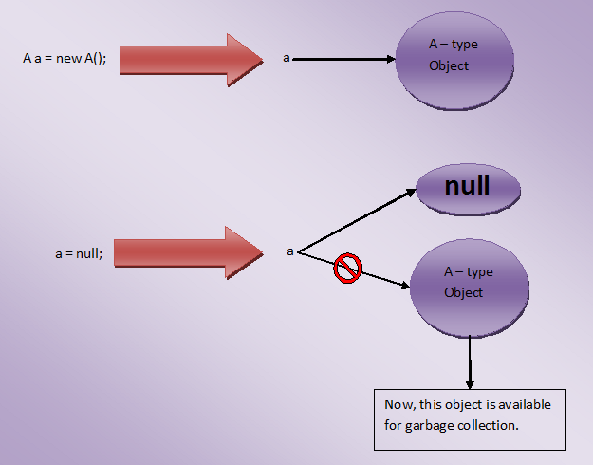

2) Soft References
The objects which are softly referenced will not be garbage collected (even though they are available for garbage collection) until JVM badly needs memory.
These objects will be cleared from the memory only if JVM runs out of memory.
You can create a soft reference to an existing object by using java.lang.ref.SoftReference class. Below is the code example on how to create a soft reference.
class A
{
//A Class
}

public class MainClass
{
public static void main(String[] args)
{
A a = new A(); //Strong Reference

//Creating Soft Reference to A-type object to which 'a' is also pointing

SoftReference<A> softA = new SoftReference<A>(a);

a = null; //Now, A-type object to which 'a' is pointing earlier is eligible for garbage collection. But, it will be garbage collected only when JVM needs memory.

a = softA.get(); //You can retrieve back the object which has been softly referenced
}
}

In the above example, you create two strong references – ‘a‘ and ‘softA‘. ‘a’ is pointing to A-type object and ‘softA’ is pointing to SoftReference type object. This SoftReference type object is internally referring to A-type object to which ‘a’ is also pointing. When ‘a’ is made to point to null, object to which ‘a’ is pointing earlier becomes eligible for garbage collection. But, it will be garbage collected only when JVM needs memory. Because, it is softly referenced by ‘softA’ object.
Look at the below picture for more clarity.
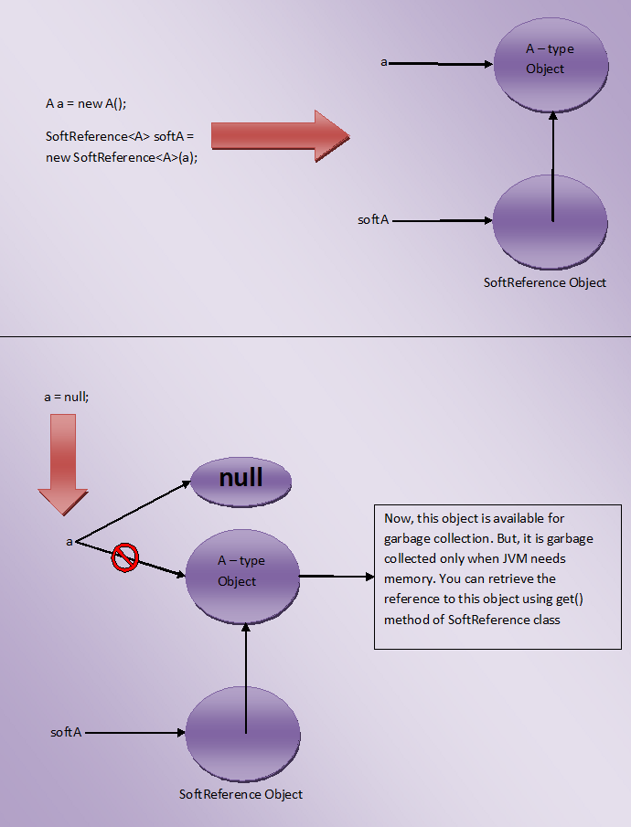
One more use of SoftReference class is that you can retrieve back the object which has been softly referenced. It will be done by using get() method. This method returns reference to the object if object is not cleared from the memory. If object is cleared from the memory, it will return null.

3) Weak References
JVM ignores the weak references. That means objects which has only week references are eligible for garbage collection. They are likely to be garbage collected when JVM runs garbage collector thread.
JVM doesn’t show any regard for weak references.
Below is the code which shows how to create weak references.

?
class A
{
//A Class
}

public class MainClass
{
public static void main(String[] args)
{
A a = new A(); //Strong Reference

//Creating Weak Reference to A-type object to which 'a' is also pointing.

WeakReference<A> weakA = new WeakReference<A>(a);

a = null; //Now, A-type object to which 'a' is pointing earlier is available for garbage collection.

a = weakA.get(); //You can retrieve back the object which has been weakly referenced.
}
}

Look at the below picture for more clear understanding.
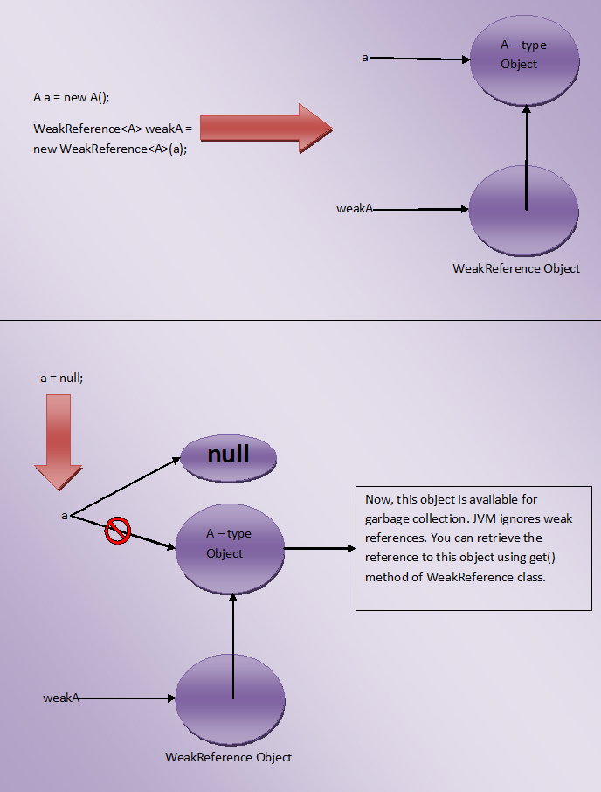
You may think that what is the use of creating weak references if they are ignored by the JVM, Use of weak reference is that you can retrieve back the weakly referenced object if it is not yet removed from the memory. This is done using get() method of WeakReference class. It will return reference to the object if object is not yet removed from the memory.

4) Phantom References
The objects which are being referenced by phantom references are eligible for garbage collection.
But, before removing them from the memory, JVM puts them in a queue called ‘reference queue’ .
They are put in a reference queue after calling finalize() method on them.
You can’t retrieve back the objects which are being phantom referenced.
That means calling get() method on phantom reference always returns null.
Below example shows how to create Phantom References
class A
{
//A Class
}

public class MainClass
{
public static void main(String[] args)
{
A a = new A(); //Strong Reference

//Creating ReferenceQueue

ReferenceQueue<A> refQueue = new ReferenceQueue<A>();

//Creating Phantom Reference to A-type object to which 'a' is also pointing

PhantomReference<A> phantomA = new PhantomReference<A>(a, refQueue);

a = null; //Now, A-type object to which 'a' is pointing earlier is available for garbage collection. But, this object is kept in 'refQueue' before removing it from the memory.

a = phantomA.get(); //it always returns null
}
}

JAXB:→

JAXB stands for Java Architecture for XML Binding. It provides mechanism to marshal (write) java objects into XML and unmarshal (read) XML into object. Simply, you can say it is used to convert java object into xml and vice-versa.

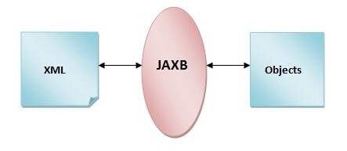

Features of JAXB 2.0
JAXB 2.0 includes several features that were not present in JAXB 1.x. They are as follows:
1) Annotation support: JAXB 2.0 provides support to annotation so less coding is required to develop JAXB application. The javax.xml.bind.annotation package provides classes and interfaces for JAXB 2.0.
2) Support for all W3C XML Schema features: it supports all the W3C schema unlike JAXB 1.0.
3) Additional Validation Capabilities: it provides additional validation support by JAXP 1.3 validation API.
4) Small Runtime Library: it required small runtime library that JAXB 1.0.
5) Reduction of generated schema-derived classes: it reduces a lot of generated schema-derived classes.

Maven :-

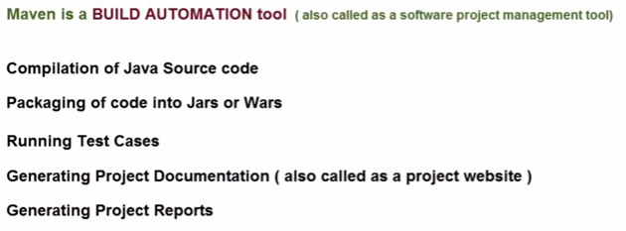

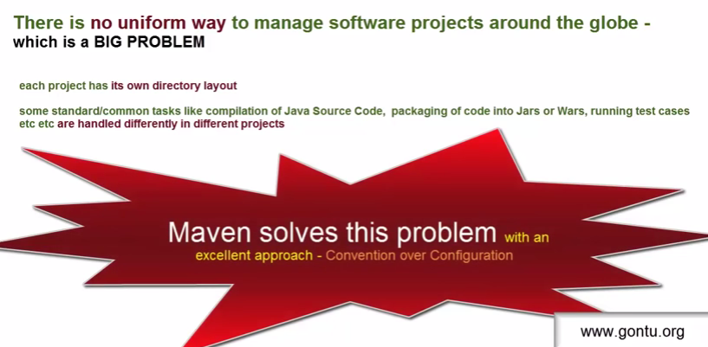

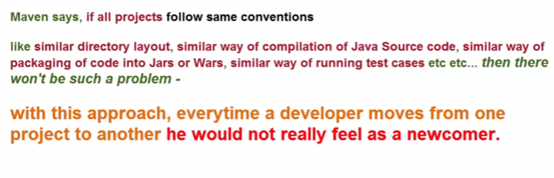

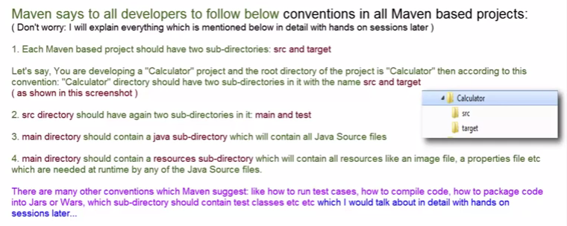

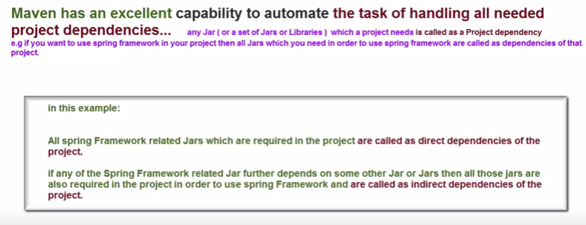

Maven Goals :->
- validate: validate the project is correct and all necessary information is available.
- compile: compile the source code of the project.
- test: test the compiled source code using a suitable unit testing framework. These tests should not require the code be packaged or deployed.
- package: take the compiled code and package it in its distributable format, such as a JAR.
- integration-test: process and deploy the package if necessary into an environment where integration tests can be run.
- verify: run any checks to verify the package is valid and meets quality criteria
- install: install the package into the local repository, for use as a dependency in other projects locally.
- deploy: done in an integration or release environment, copies the final package to the remote repository for sharing with other developers and projects.

